Level 6 Production Project
Project Initiation
Name: Aayam Regmi | Student I.D.: 77466864
Course: BSc (Hons) Computing | Supervisor’s Name: Mr. Saroj Sharma
Final Project Individual Aim & Objectives
Title of my Project: Comparative Evaluation of Vision-Based Finger Tracking for Piano Interaction

Aim of my Project: To evaluate robustness, accuracy and real-time performance of two or more open-source vision-based finger tracking systems during interaction with a real piano acting as a ground truth. Considering lighting conditions, finger and hand occlusion challenges, and user diversity (hand size and skin tone) the aim is to determine whether these variables affect the consistency, performance and accuracy across different pretrained models.
Objectives of my Project:
- To develop a fundamental understanding of vision-based hand and finger tracking algorithm techniques including temporal tracking, landmark detection and handing occlusions between overlapping hands and fingers.
- To analyze existing computer vision finger tracking approaches in real-time.
- To design a system with a camera programmed to work with finger tracking and a real electronic piano for ground truth interaction.
- To establish a camera-to-keyboard calibration system that maps pixel coordinates to physical key positions.
- To compare multiple pretrained finger-tracking models (MediaPipe Hands, OpenPose, MoveNet) under same experimental conditions and evaluate the result.
- To define and implement quantitative performance metrics for finger tracking evaluation.
- To analyze different lighting situations and its effect on tracking accuracy and stability.
- To consider tracking performance across users with different hand sizes.
- To assess performance bias when using tests with broad skin tone categories.
- To investigate the impact of finger and hand occlusion on tracking accuracy and recovery behavior.
- To evaluate trade-offs between accuracy and real-time performance between different pretrained models and tabulate the results.
- To identify current limitations of approaches in vision tracking models in piano interaction contexts and recommend targeted improvements.
- To establish a reproducible experimental protocol for evaluating hand-tracking systems in the context of music and instruments.

Specification of my Product:
Functional Requirements
# | Functional Requirement | Description / Scope | MoSCoW
1 | Finger landmark tracking using vision models | Using preexisting finger tracking models with a fixed camera above a real piano | Must
2 | MIDI ground truth capture | Establish ground truth with digital MIDI output of Casio CTK-2400 | Must
3 | Temporal synchronization & comparison | Tabulate comparison between different models, fingertip position and keypress times | Must
4 | Support multiple open-source models | Integrate & compare at least MediaPipe Hands, OpenPose, MoveNet (Thunder) | Must
5 | Camera-to-keyboard spatial calibration | Map pixels to physical piano or establish virtual landmarks | Must
6 | Data logging system | Store x,y coordinates, video frames and timestamps provided by MIDI | Must
7 | Keypress event analysis | Calculate MIDI keypress and fingertip Euclidean distance, marking active finger or failure | Must
8 | Quantitative performance metrics calculation | Calculate primary metric MPJPE and secondary metrics like loss rate, temporal jitter, occlusion recovery time, FPS latency | Must
9 | Controlled variation of experimental conditions | Test different scenarios like hand size, skin tones and occlusion | Must
10 | Statistical comparison of models | Perform statistical tests (e.g. t-test) to compare models across conditions | Must
11 | Model selection justification | For piano interaction provide scientific reasoning and recommendations for the best suitable model | Must
12 | Reproducible experimental protocol | Record a detailed protocol for future enhancements and recreations | Should
13 | Evaluation under additional models | Include one or more extra models beyond the main three (e.g. BlazePose, HRNet, custom fine-tuned, etc.) | Could
14 | Real-time visualization | Add detection landmark and active finger indicator live overlay interface during data collection | Should
15 | Automatic detection & annotation of occlusion events | For severe occlusion cases automatically classify and log frames | Could
16 | 3D hand pose estimation | Use models that output 3D coordinates with multi camera system | Won't
17 | Mobile / embedded deployment | Deploy the final comparison system on mobile devices or edge hardware | Won't
18 | Multi-camera / multi-view tracking | Use more than one camera for improved accuracy | Won't
19 | Real-time audio feedback during playing | Generate sound or visual feedback based (gamification) | Won't

Non-Functional Requirements
# | Non-Functional Requirement | Description / Expectation | MoSCoW
1 | Research-focused with functional prototype | Deliver meaningful research insights supported by a working prototype system | Must
2 | Fair & controlled comparison conditions | models evaluated under identical hardware, lighting, camera position & setup | Must
3 | Development using Python & established open-source libraries | Use Python + OpenCV, MediaPipe, MIDI libraries, stats & plotting as primary tools | Must
4 | Ethical compliance & participant protection | Follow university ethics guidelines, obtain approval, informed consent, anonymized & secure data storage | Must
5 | Reasonable real-time performance | Achieve at least 15–20 FPS on the development machine during data recording | Should
6 | Good code quality, documentation & reproducibility | Clean code structure and comprehensive README | Should
7 | Basic robustness & graceful error handling | System logs errors and continues operation (no full crash) | Could

Research:
Finger tracking systems are used in many fields today, including human-computer interaction (HCI), virtual and augmented reality, and medical assessments [1]. In modern frameworks for finger tracking, accuracy is the deciding factor for usability, and often research done under such libraries have controlled datasets that might not account for multiple real-world interaction challenges [2]. From lighting variations to finger occlusion and user diversity, a piano has many of these challenges that can test these frameworks' accuracy [3].
Due to vision-based tracking systems relying on RGB image information, skin tone is included in this project as an evaluation factor [4]. Multi-range RGB values introduce different contrasts and reflections under different lighting conditions, which can influence landmark detection evaluation [5]. Studies conducted under vision systems can exhibit disparities in performance across demographic groups [6]. Multiple pretrained models might be trained under biased RGB values with limited demographic diversity [7]. With broad skin tone assessments, this study will be able to assess potential bias in the system, determining potential dataset improvements for vision tracking models [4][7].
Hand size is also considered, as differences in finger length and joint spacing may affect landmark localization accuracy [2]. Piano interaction presents unique challenges, including rapid finger movements, frequent hand occlusion, and proximity of fingers, making it an ideal testbed for tracking system robustness [3][8]. Additionally, multi-model tests can determine if certain behaviors are model-specific or a generalized problem in terms of finger tracking systems [2][9].

Evaluation:
The average Euclidean distance between predicted fingertip locations by the open-source models and the corresponding pressed key location is the Mean Per-Joint Position Error (MPJPE) [10]. MPJPE will be the primary performance metric for this research. If MPJPE is a negligible value like <10mm, the tracking will be considered accurate [10][11].
Secondary metrics:
- Loss rate (percentage of frames where hands are not detected)
- Temporal jitter (standard deviation of joint positions across continuous frames)
- Occlusion recovery time (frames required to re-establish tracking)
- Latency (FPS) [2][9][12]
The dataset and results will be categorized by the following standards:
- Lighting categorization:
- standard indoor 400-500 lux
- bright 800-1000 lux
- dim 150-200 lux [2]
- Hand size categorization: Small · Medium · Large [2]
- Skin tone category method: Fitzpatrick Scale [4][13]
Statistical analysis will be paired with a t-test (p<0.05) to compare model performance [2][9].
Validation of ground truth generation will be done by annotating 10% frames [11].

Project Planning & Methodology
Project Planning:
Task Sheet
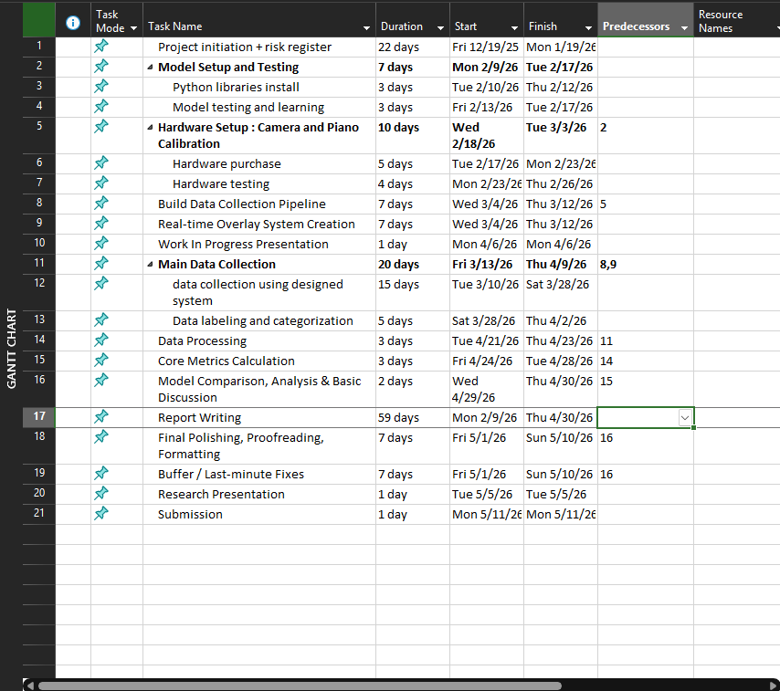

Gantt chart
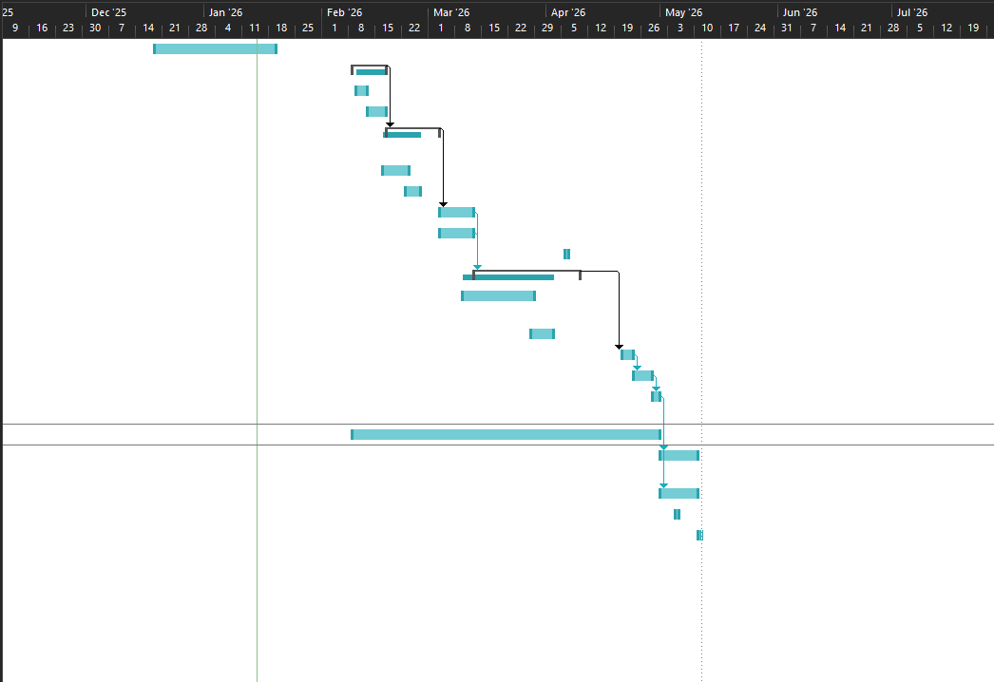
Project Timeline
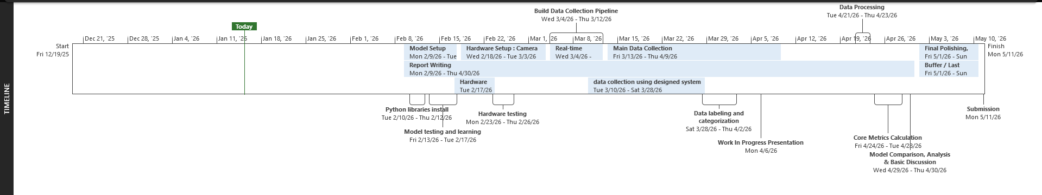
Methodology:
This project adopts a Rapid Application Development (RAD) methodology because the data collection and processing will need higher priority and time after the system is developed.[14] Other methodologies such as waterfall emphasizes a straightforward development with no turnback’s, while RAD prioritizes rapid development and iterations of a working prototype. For comparative research projects like this, RAD is appropriate as core functional testing platform is required rather than product ready application. RAD allows continuous feedback and changes from the supervisor’s advice as well.
Resources
The software I require to complete my Project successfully:
Item | Source
Windows OS | Own
Python 3.8+ | Own
MediaPipe | Open Source
OpenCV | Open Source
MIDI Interface Libraries (mido, python-rtmidi) | Open Source
Statistical Analysis Software (scipy, statsmodels) | Open Source
Data Visualization (Matplotlib, Seaborn) | Open Source
Version Control (Git, GitHub) | Open Source
Microsoft Word | Own
Microsoft Excel | Own
Microsoft PowerPoint | Own
Web browsers: Google Chrome | Own

The hardware I require to complete my Project successfully:
Item | Source
Laptop / PC (16GB RAM, i7-14th gen CPU, RTX 5070) | Own
USB Camera (30 FPS, 1080p resolution) | Own
Casio CTK-2400 Digital Piano | Own
USB A-to-B Cable (for MIDI connection) | Purchase
Camera Tripod or Mount | Purchase
Digital Lux Meter (for lighting measurement) | Purchase
Colored Calibration Markers | Purchase

Human Resource
I am working on my Project with the following people
Name: Aayam Regmi | Role:  Module Leader: Dr. Rohit Raj Pandey  Supervisor: Mr. Saroj Sharma

Initial Bibliography
1. Zhang, F., et al. (2020). MediaPipe Hands: On-device Real-time Hand Tracking. arXiv preprint arXiv:2006.10214.
2. Jo, H., & Kim, S. (2022). Comparative Analysis of OpenPose, PoseNet, and MoveNet Models for Pose Estimation in Mobile Devices. Traitement du Signal.
3. Liang, H., et al. (2016). Barehanded Music: Real-time Hand Interaction for Virtual Piano. ACM Symposium on Interactive 3D Graphics and Games.
4. Buolamwini, J., & Gebru, T. (2018). Gender Shades: Intersectional Accuracy Disparities in Commercial Gender Classification. Proceedings of Machine Learning Research.
5. Groh, M., et al. (2023). Robustness Evaluation in Hand Pose Estimation Models using Metamorphic Testing. arXiv preprint.
6. Mehrabi, N., et al. (2021). A Survey on Bias and Fairness in Machine Learning. ACM Computing Surveys.
7. Cho, S., et al. (2023). Consensus and Subjectivity of Skin Tone Annotation for ML Fairness. NeurIPS.
8. Hiranaka, A. (Year). AR Piano Playing Using Real-Time Hand Tracking.
9. Kim, et al. (2022). Comparative Analysis of Skeleton-Based Human Pose Estimation. MDPI Future Internet.
10. Mueller, F., et al. (2018). GANerated Hands for Real-Time 3D Hand Tracking from Monocular RGB. CVPR.
11. Salz, D., & Azam, F. (2019). Playing a Virtual Piano with Dynamics. Stanford University Report.
12. Cao, Z., et al. (2019). OpenPose: Realtime Multi-Person 2D Pose Estimation using Part Affinity Fields. IEEE TPAMI.
13. Fitzpatrick, T.B. (1988). The Validity and Practicality of Sun-Reactive Skin Types I Through VI. Archives of Dermatology.
14. Martin, J. (1991). Rapid Application Development. Macmillan.

